Guide: Azure App Registration & Dynamics 365 Application User Setup

1. Overview
To allow an external application (API/Worker) to connect to Dynamics 365 without a physical user logging in, we must register an application in Azure and add it as a trusted "Application User" in the Dataverse environment.

2. Prerequisites
- Azure Access: Permission to register applications in the Azure Portal.
- Dynamics Access: System Administrator role in the Power Platform Admin Center.

Part 1: Create App Registration in Azure
- Log in to the Azure Portal (portal.azure.com).
- Search for and select App registrations (or Microsoft Entra ID > App registrations).
- Click + New registration in the top menu.
- Register an application:
  - Name: Enter a meaningful name (e.g., Dynamics365 Integration App).
  - Supported account types: Select Accounts in this organizational directory only (Single tenant).
  - Redirect URI: Leave blank (not required for S2S).
- Click Register.
Copy Critical IDs
Once created, you will be on the Overview page. Copy the following values to a secure location (e.g., Notepad or Password Manager); you will need them for your code configuration.
- Application (client) ID
- Directory (tenant) ID
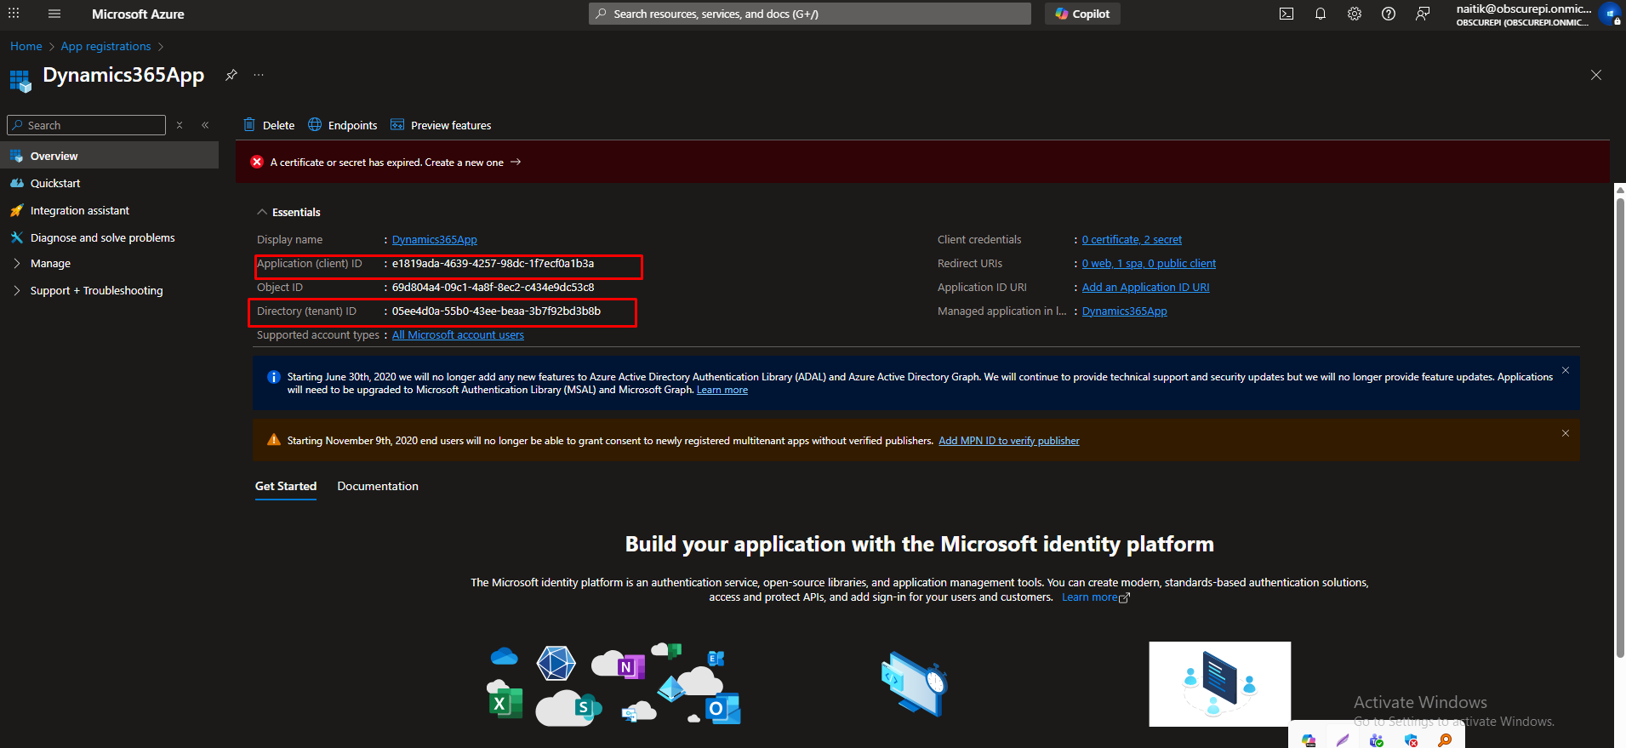

Part 2: Generate Client Secret
- In the left menu of your App Registration, click Certificates & secrets.
- Click + New client secret.
- Description: Enter a description (e.g., D365 Connector Key).
- Expires: Select a duration (e.g., 180 days or 365 days).
- Click Add.
- 🛑 CRITICAL: Immediately copy the Value (NOT the Secret ID).
  - Note: This value will be hidden forever once you leave this page. If you lose it, you must generate a new one.
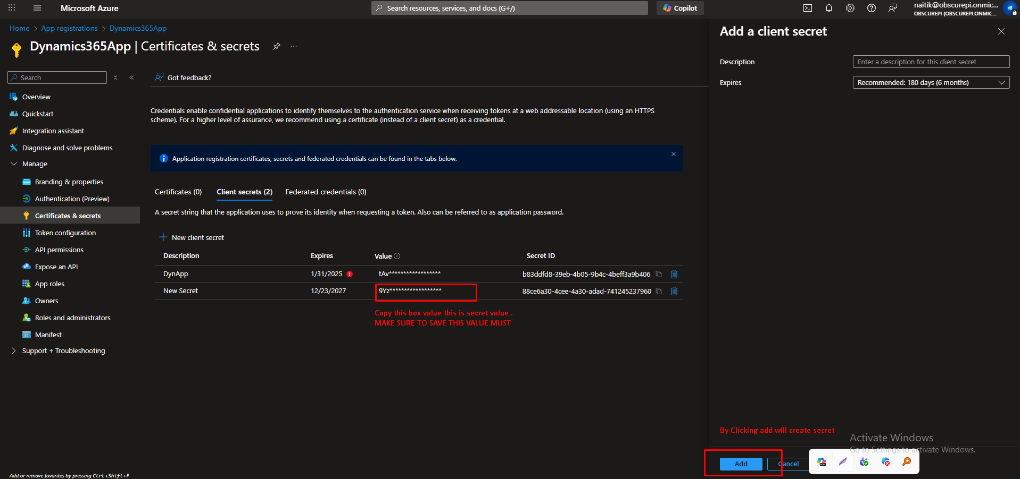

Part 3: Grant API Permissions (Dynamics CRM)
- In the left menu, click API permissions.
- Click + Add a permission.
- Select Dynamics CRM (It may be under the APIs my organization uses tab if not visible immediately).
- Click Delegated permissions.
- Check the box: user_impersonation.
- Click Add permissions.
- Grant Consent:
  - Look at the status column. If it says "Not granted", click the Grant admin consent for [Your Org] button above the list.
  - Click Yes to confirm.
  - Status should change to a green checkmark.
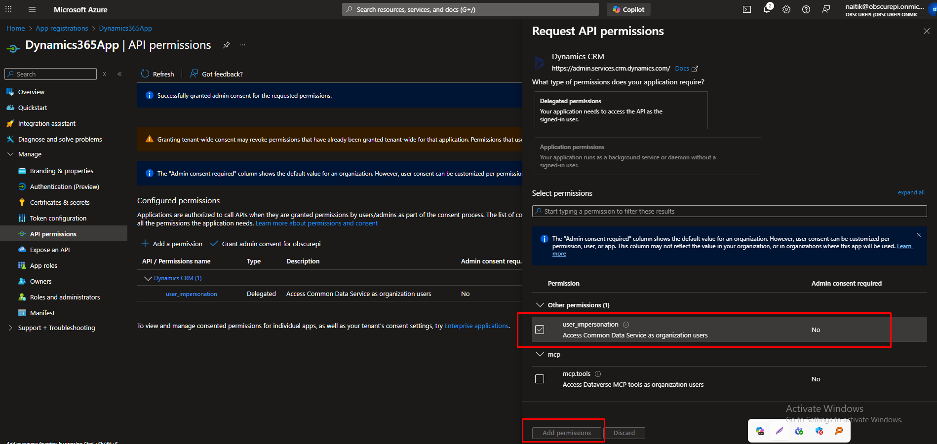
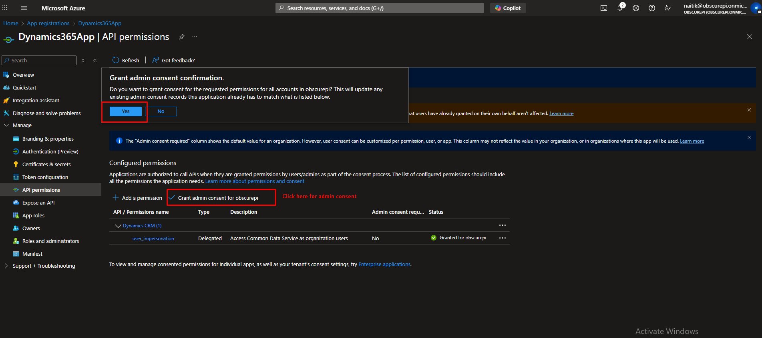

Part 4: Add Application User to Dynamics 365
Now that the App exists in Azure, we must tell Dynamics 365 to trust it.
- Log in to the Power Platform Admin Center (admin.powerplatform.microsoft.com).
- On the left menu, select Environments.
- Click on the name of the target environment (e.g., Production).
- On the right side, under Access, click See all under "Users" or locate Settings > Users + permissions > Application users.
- Click + New app user.
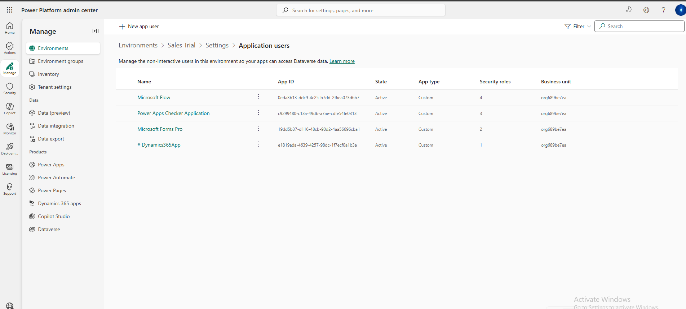
- Add the App:
  - Click + Add an app.
  - Search for the name of the Azure App you created in Part 1 (e.g., Dynamics365 Integration App).
  - Select it and click Add.
- Business Unit: Select your root business unit (usually pre-selected).
- Security Roles (Crucial):
  - Click the Edit (pencil icon) next to Security roles.
  - Select System Administrator.
  - Note: You can give stricter roles, but for full data access/search, System Admin is recommended for backend services.
  - Click Save.
- Click Create.
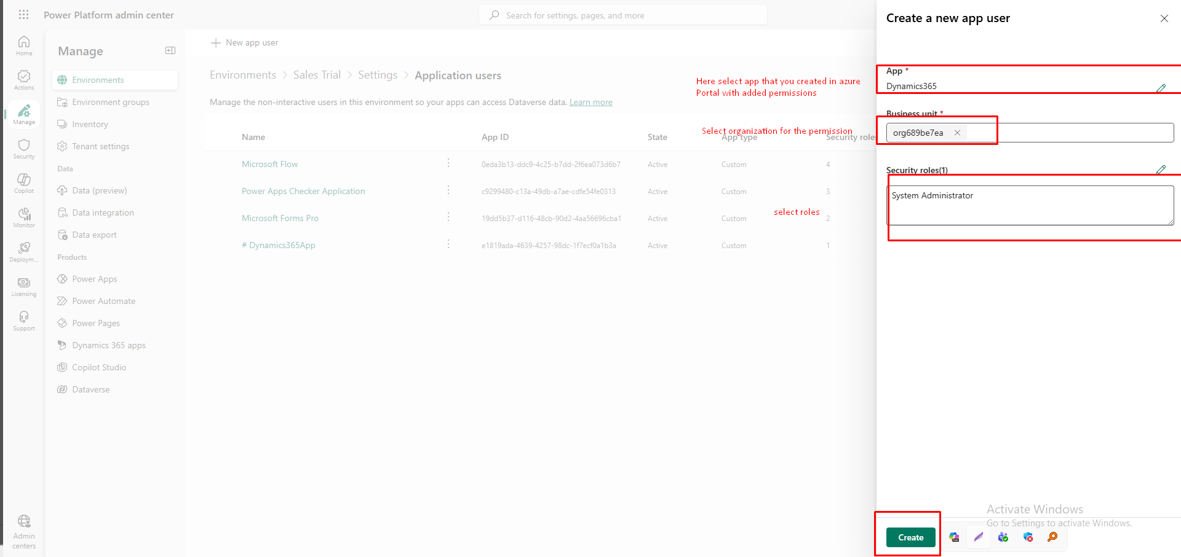

5. Summary of Configuration Values
For your C# Application to connect, you now have the three required components:
C# Variable | Source
ClientId | Azure Portal > App Registration > Overview > Application (client) ID
ClientSecret | Azure Portal > Certificates & secrets > Value
EnvironmentUrl | Power Platform Admin Center > Environments > Environment URL

